Balanced and Unbalanced Forces

For each of the questions below identify whether the forces are balanced or unbalanced. Write the resultant force and its direction. The first two questions have been completed as examples.

2. 
1.
6.
8.
7.
9.
5.
12.
11.
10.
4.
3.
____________________________________________
____________________________________________
____________________________________________
____________________________________________
____________________________________________
____________________________________________
____________________________________________
____________________________________________
____________________________________________
____________________________________________
Balanced
0N stationary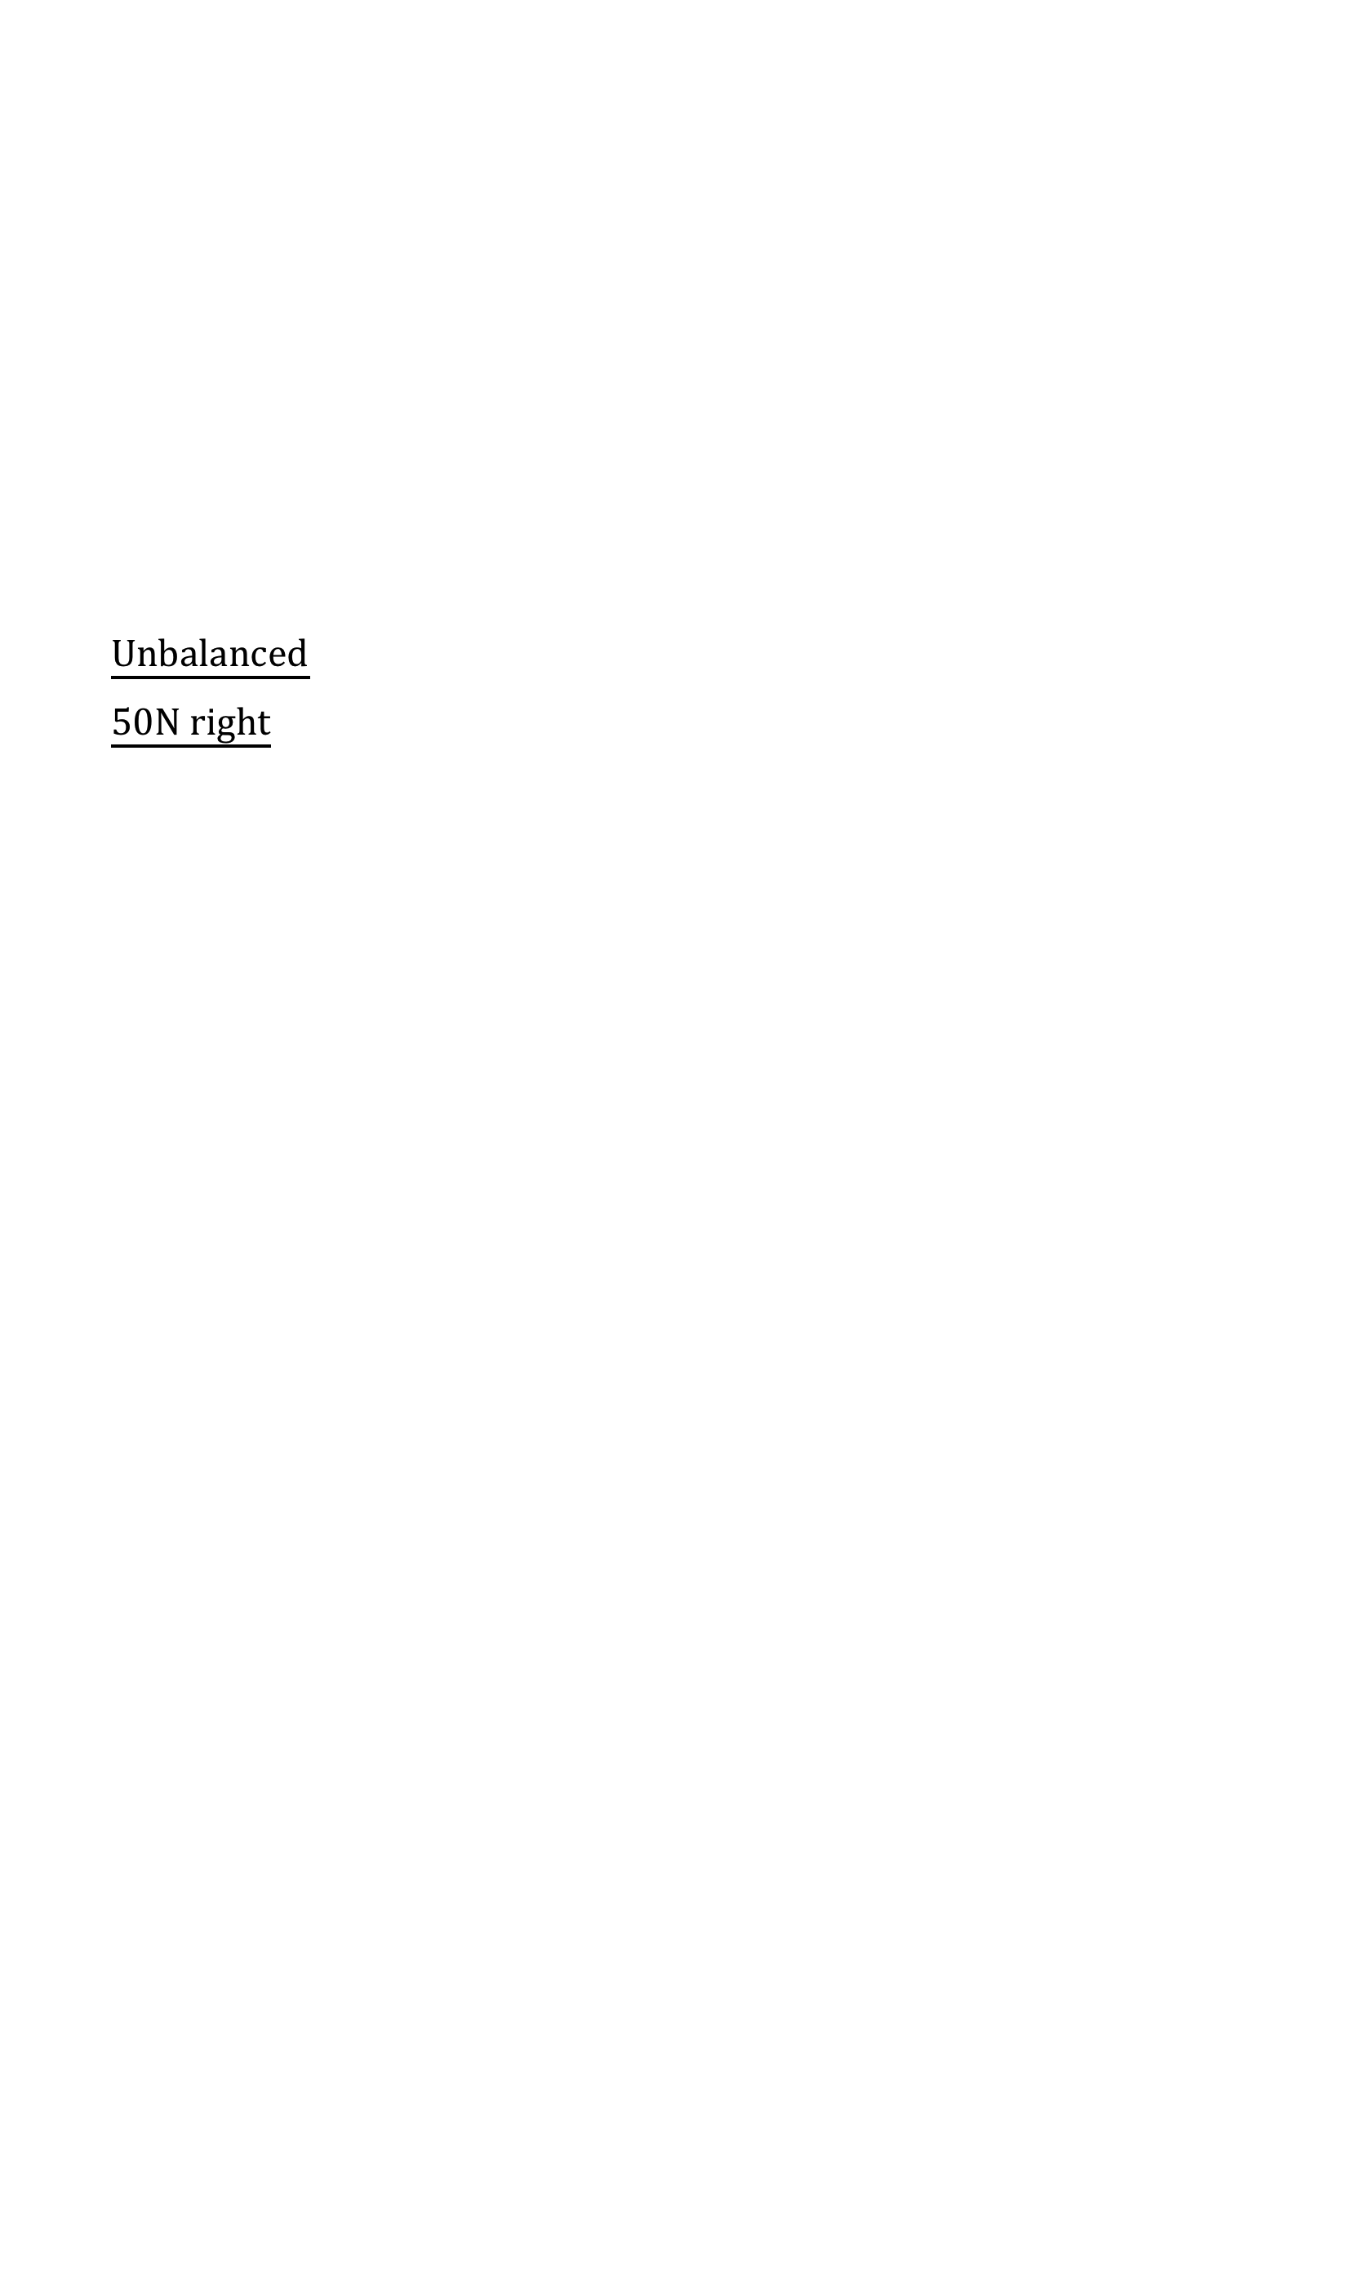
Unbalanced
50N right
100N
650N
145N
445N
3872N
3872N
7N
446N
295N
2N
2N
90N
97N
58N
28N
15N
30N
40N
50N
60N
40N
10N
10N
10N
Answers:

3. Unbalanced 10N left
4. Unbalanced 70N right
5. Unbalanced 300N left
6. Unbalanced 635N left
7. Balanced 0N stationary
8. Unbalanced 21N right
9. Unbalanced 237N right
10. Unbalanced 349N right
11. Unbalanced 50N left
12. Balanced 0N stationary

